Before Pandemic default 4%, Post pandemic 20%

Want predictive model to predict for 1 person, likelihood of default/time before payment

* Who and when to chase for payment, who to apply harsh methods
* Challenge: which models to apply: yes/no, percentage
* Challenge: need model output to be integrated into Vespucio and bring value, other people need to understand
* Two main documents
* 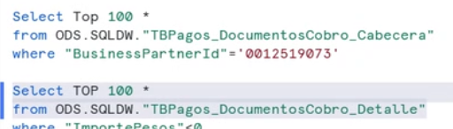
* Business Partner ID: unique for each client
* FethchaEmsision invoice date
* FetchaV due date (usually 16 days or more if holiday)
* Fechcompensation: date transaction was paid
* Dias compensation: difference btw payment and due date, may pay in advance negative values, 0 on due date
* OperationPricipal: collection agency, but we want to focus on costs
  + No info on the collection process
  + Only collection process after 600 pesos
* CuentaContract: 1 client could have multiple contracts
* Products: there are 2, T if they have device, E if they do not (manual pass, will take time for invoice)
* HoraCreation: date transaction created
* Status of compensation: 3 categories: 0 is unpaid, 9 is paid, 8 is unpaid but

cancelled(after long time, run a writeoff)

* Partial payment not an option
* Cost associated with collection companies
* How many contracts each client has
* How many vehicles the client has
* Type of operation: device/tool, same as products, if don’t have device, need to invoice later based on number of car
* Divide yealy data based on compensation date
* Should also have data of chilean FICO score